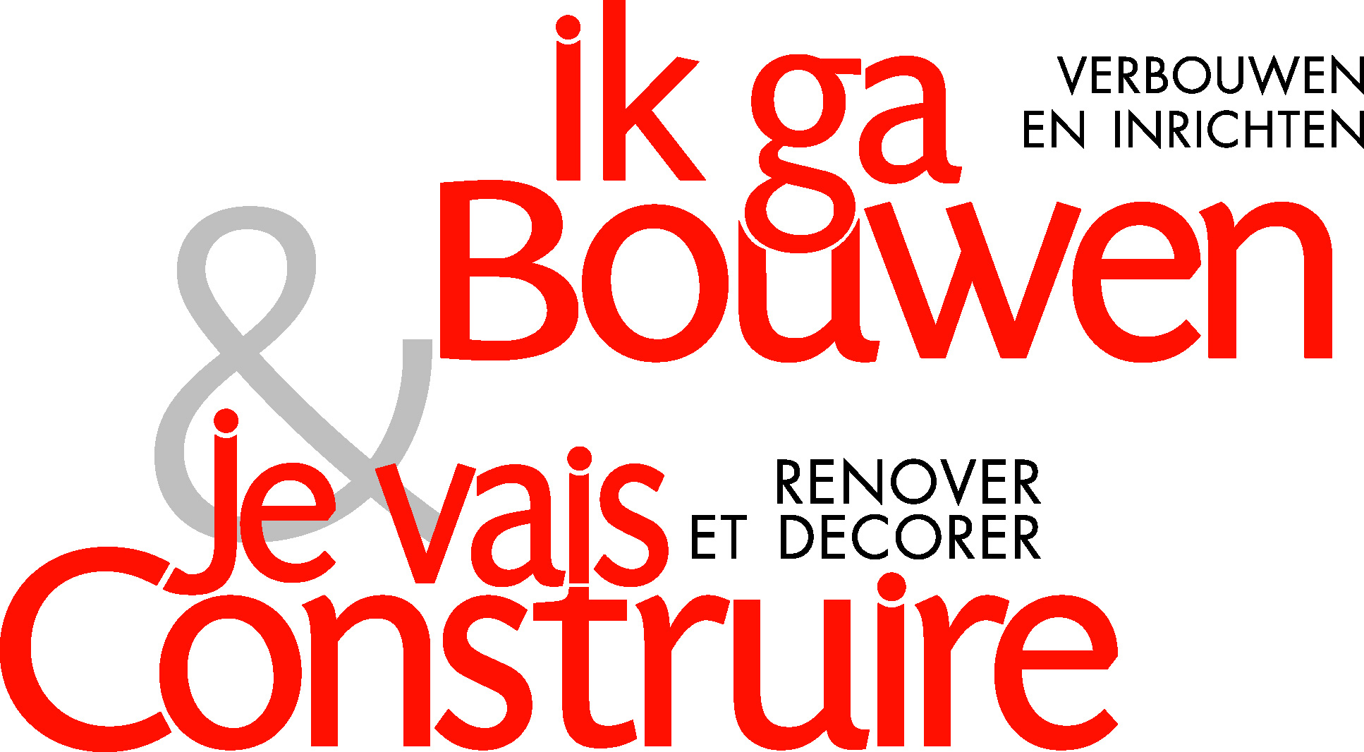

PRESS RELEASE
7 June 2005

‘Ik ga bouwen’ magazine takes over bouwmeester.be website

Media Office, which publishes monthly magazines ‘Ik ga bouwen’ and ‘Je vais construire', announces that it has just acquired the www.bouwmeester.be website.

www.bouwmeester.be was set up in 2001 by Luc Desloovere, who has almost 20 years’ experience of the Belgian building world. In just a few years www.bouwmeester.be has grown into Belgium’s number one reference site for building and renovation. The intention is to expand it further among the other Roularta websites, with strong backing from the various Roularta Media Group printed media.

The website will shortly be extended with a French-language version, www.maitrebatisseur.be, to give advertisers a country-wide reach.

Media Office, a sister company of Roularta Media Group, specializes in inspirational and practical publications for people looking to build, renovate or and furnish properties. Monthly magazines ‘Ik ga bouwen’ and ‘Je vais construire’ have been part of its media portfolio for over 30 years. Media Office also operates in the directories and events sector, with names like ‘Bouwen/Bâtir’, ‘de Vlaamse Renovatiedag’ (Flemish Renovation Day), ‘De Kijkwoningengids’ (Show Flat Guide) and ‘de Kijkwoningendag’ (Show Flat Day). Special projects include ‘BuildingServices’, with the successful BuildingBox for builders and renovators.

This take-over once again proves Media Office's prominent position in this market segment, with total sales of EUR 2.1 million and a broad range of media directed at builders and renovators.

Luc Desloovere, the founder and inspirer of www.bouwmeester.be will take care of the commercial and technical management and remains responsible for expanding this project within Media Office. Further info from Luc Desloovere at info@bouwmeester.be or 0475 713 567. The publisher function has been taken by Bob De Meyer. Roularta IT-Services is providing technical support

Contact persons | Rik DE NOLF | Bob DE MEYER
Tel: | + 32 51 266 323 | + 32 3 201 52 71
Fax: | + 32 51 266 593 | + 32 3 201 52 72
e-mail: | rik.de.nolf@roularta.be | bob.de.meyer@roularta.be
URL: | www.roularta.be | www.ikgabouwen.be  www.bouwmeester.be

